LAMS OVERVIEW

What is LAMS?

LAMS (“Learning Activity Management System”) is an Australian invention that has become the world’s leading software for creating and running digital lesson plans. Its unique drag-and-drop interface transforms lesson planning into a simple, visual experience (see below).

The system is being used in all forms of education: K-12 schools, vocational training, higher education, adult/community learning and corporate training. The greatest interest in LAMS to date has been in K-12 schools and universities, followed by vocational training.

Teachers use LAMS to design a sequence of learning activities for students that includes content (Learning Objects) and collaborative tasks. LAMS then “runs” the sequence of tasks for students, and provides teachers with a monitoring environment to track student progress.

Teachers can design and run a lesson plan in under 10 minutes using LAMS. The lesson plans can also be shared, so that other teachers can use (and adapt) LAMS sequences.

LAMS is successful in a variety of educational settings, eg, in K-12 it can be used for:
- live collaborative activities in a computer lab at school,
- online homework activities completed at home or in the library,
- individual instruction or small group work in classrooms with few computers,
- dynamic presentations in conjunction with an interactive whiteboard,
- personalised learning and presenting content (such as TLF Learning Objects), and
- collaboration across several schools, even schools in different countries.

Rather than being sold as proprietary software, LAMS is being released as freely available “open source software” for the public good of education by the non-profit LAMS Foundation (backed by Macquarie University). A separate commercial services company (LAMS International Pty Ltd) offers optional fee-based technical support, training, etc.

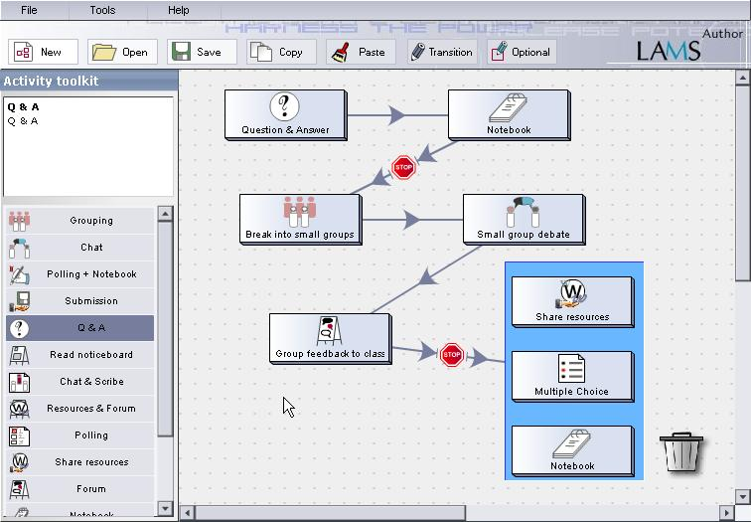
Who is using LAMS? Who is supporting LAMS?

There are hundreds of organizations from over 20 countries that are trialling LAMS, and LAMS articles have been published on the Web in six languages.

As LAMS software has no cost, LAMS relies on contributions from key users. The LAMS Foundation Ltd seeks support from governments, charities and others around the world. Apart from significant assistance from Macquarie University and James Dalziel, some examples of supporting organisations to date are listed below:

- UK Department for Education and Skills together with the
UK Specialist Schools Trust – supporting over 40 UK schools
- New Zealand Ministry of Education – supporting over 30 NZ schools, together with polytechnics and universities
- UK Joint Information Systems Committee (“JISC”) supporting 15 Further Education and 16 Higher Education institutions in the UK, and development work
- Oxford University
- Cambridge University
- Australian National University & University of Canberra
- Nanyang Technological University, Singapore
- University of Sussex
- National Library of New Zealand
- Tasmanian Department of Education

What are the benefits of LAMS?

LAMS has received enthusiastic endorsement from e-learning experts around the world. For example, Professor Diana Laurillard (Director, E-learning Strategy Unit, UK DfES) has stated that she sees the potential for LAMS to be used in every school in the UK in the future. Formal independent evaluations of LAMS are being conducted by JISC and BECTA (UK).

Research on LAMS demonstrates that it is a transformational technology for the education sector with many types of benefits for teachers, students, parents and administrators, eg:

Low achieving boys: In a key UK trial, LAMS was highly successful in a secondary boys school with some low achieving students. Boys were particularly enthusiastic about the way LAMS brought familiar collaborative technologies into the classroom. Teachers were enthusiastic about the way LAMS increased discussion and participation, reduced workloads (through faster preparation, and sharing of designs) and increased achievement levels. A survey showed that while only 16% of boys were comfortable answering teacher questions in a typical classroom setting, 83% of the same boys were comfortable answering in LAMS. A four minute video about LAMS in this school is available at: http://www.jisc.ac.uk/uploaded_documents/kemnal.wmv

Indigenous higher education students: Use of LAMS at Macquarie University within the Indigenous Community Management Program has led to high levels of student engagement with subject matter and technology. Students commented that the collaboration and discussion fostered by LAMS was felt to be particularly appropriate to their learning styles, unlike other e-learning courses elsewhere with a heavy emphasis on content, or large lecture theatres with little interaction. Some students found using LAMS so transformational that they wish to change their career to education, using tools like LAMS.

High ability humanities students: At a Sydney private girls school, LAMS has been used to extend the learning experience of gifted and talented students in English through online collaboration tasks. Activities have run over several weeks including tasks both within school classes and out-of-class tasks (done at home or in the library).

Vocational training in motor mechanics: In a UK vocational training college, online LAMS tasks have been used to complement small group face-to-face teaching in motor mechanics.

Teacher training: LAMS is being used in the UK and Australia for university teacher training courses. Trainee teachers use LAMS within their course to assist their own learning, and then develop LAMS sequences for use in schools with their K-12 students.

Advanced bioinformatics: A UK university is using LAMS for advanced courses in bioinformatics. Students use LAMS to search and analyse complex gene databases, and then collaborate on the interpretation of outcomes.

School science using live data from the internet: Secondary school science teachers are teaching weather topics using LAMS by getting students to use websites with live weather data, combined with small group discussion and interpretation of this data in LAMS.

Standardising curriculum: LAMS provides a foundation for standardising curriculum across different groups of teachers/disciplines. At one university, LAMS has been used to standardise the teaching of introductory statistics across a range of disciplines (psychology, engineering, medicine, sociology). LAMS can also be used to achieve consistency by mapping school curriculums between different states or countries by providing a “pedagogical meta-model”.

Portfolio records of activities: LAMS allows students to capture a rich record of their online activities and store these in a portfolio. This provides the potential for later reflection on past activities across a lifetime of learning, as well as automated reporting of activities and outcomes to parents, administrators and government agencies.

Sharing of good practice: Once a teacher designs a digital lesson plan in LAMS, this can be shared with other teachers, who can also use it, or adapt it to their own context. This unique feature of LAMS allows teachers to collaborate with each other via a community website to share libraries of good practice digital lesson plans. These teachers can later report on experiences of using shared sequences with their students. This feature also provides the opportunity for Government Educational Departments to centrally provide quality-assured digital lesson plans according to curriculum goals and based on best practice methods.

National Delivery Platform for Learning Objects and activities: LAMS could provide a national, open, flexible delivery system for e-learning activities and content. It could also manage Learning Object distribution and delivery. The recent AFUET report from DEST recommends exploring the use of LAMS for this purpose (Part B, p26/27).

Next Steps for LAMS

The official global launch of LAMS as freely available open source software is scheduled for April, 2005. Government officials from Australia and New Zealand, educational leaders, pedagogy experts, and LAMS supporters are expected to join in a celebration of the release of a system that could transform education more powerfully than any previous technology. Following this release, LAMS will be actively promoted across the world for use in all education sectors both in the developed and developing world.

For further details contact: Professor James Dalziel, Director, Macquarie E-learning Centre of Excellence (MELCOE) and Director, LAMS Foundation. Email: james@melcoe.mq.edu.au LAMS website: www.lamsinternational.com

